**Malloc to alloca**

Didn’t finish optimization because of the fail: “Assertion New->getType() == getType() && replaceAllUses of value with new value with different type”.

IR programs for checking correctness:

1. 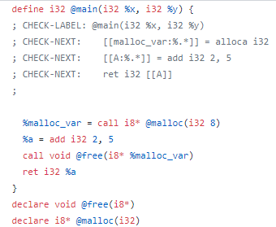
2. 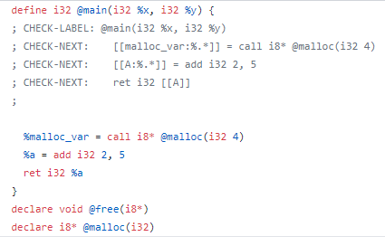
3. 